

Daily Progress Report

Installation / Location | PS-3
Subject | Corrosion Monitoring Activities
Contract Number | LC241047A0
Assigned Axess Representatives | Stuart Dunthorne
Date of Issue | 17-07-2025

Activities Summary
Work activities continued today, with Coupon and ER Probe locations being serviced on PS3-B Upper Deck and Main Deck. Further details as follows.

Time | Activities
06:00 to 07:00 | Awaiting gas test & permit issue
07:00 to 11:30 | Replace ER Probes at 2 locations and attempt retrieval at 1 other ER Probe location. Retrieve & replace coupons at 1 location
11:30 to 12:30 | Lunch
12:30 to 16:30 | Retrieve & replace coupons at 2 locations and external service of 1 ER Probe location. Move equipment to PS3-D
16:30 to 18:00 | Reporting

Locations Serviced Summary
Tag No | Line Description | Work Completed
53-XCP-972 | 12-P-532221-1144  12” Gas Line from V-5366 MP Separator to E-4302 | Removed old ER Probe and installed new 5” T10 Cylindrical ER Probe. All pressure retaining seals replaced. Probe reading obtained
53-XCP-1132 | 6-GP-532095-15150  6” HP Gas from Arab-C BH27 WHJ to PS3-B Production Manifold | Removed old ER Probe and installed new 6.5” T10 Cylindrical ER Probe. All pressure retaining seals replaced. Probe reading obtained
53-XCC-945 | 12-OC-530093-15144X  12” Oil Line from Production Manifold to Test Header | 3” Strip Coupons Removed & Replaced. All pressure retaining seals replaced
53-XCP-946 | 12-OC-530093-15144X  12” Oil Line from Production Manifold to Test Header | Attempted to replace the old ER Probe but steel structure obstructs retrieval tool pressure gauge/bleed assembly
53-XCC-1430 | 12-OC-530234-15151  12” Oil Inlet to V-5307 | 3” Strip Coupons Removed & Replaced. All pressure retaining seals replaced
53-XCP-1429 | 12-OC-530234-15151  12” Oil Inlet to V-5307 | Cap removed, threads brushed and re-greased
53-XCC-1001 | 14-OC-530274-31441M | 3” Strip Coupons Removed & Replaced. All pressure retaining seals replaced

Tag No | Line No / Description | Pressure  (psi) | A/F Orientation | Scope of Work | New Probe Size / Specification | Probe Readings | Date | Tool Used | Location Access | Remedial Actions
53-XCP-972 | 12-P-532221-1144  12” Gas Line from  V-5366 MP Separator to E-4302 | 150psi | 9 o Clock | Install New ER Probe | 5” Cylindrical T10  4500-T10-K03005-5.00-0-0 | Check – 769  Div – 96.4  M.Loss – 0.481  CR – N/A | 17-07-2025 | 25” | Access OK | None  Required
Access Fitting Picture |  |  |  | Removed Device |  |  | New Probe
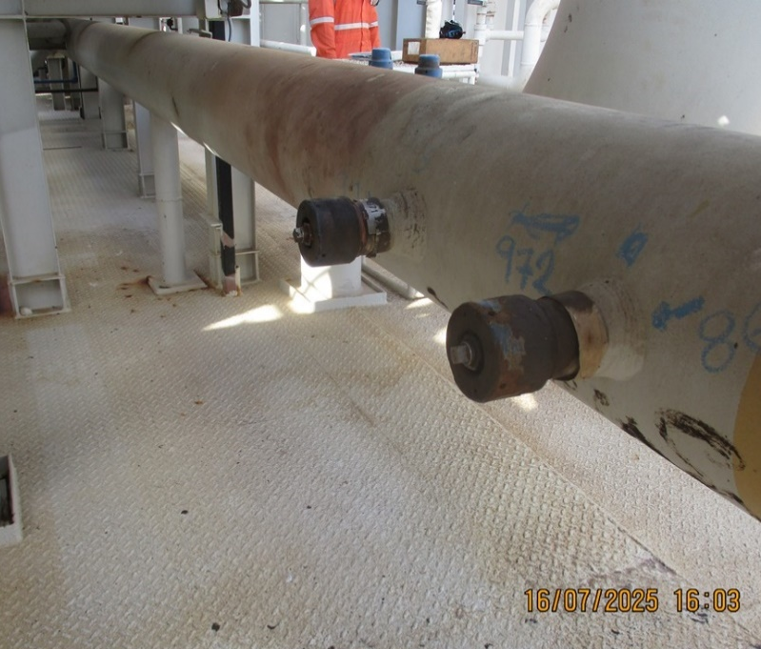 |  |  |  | 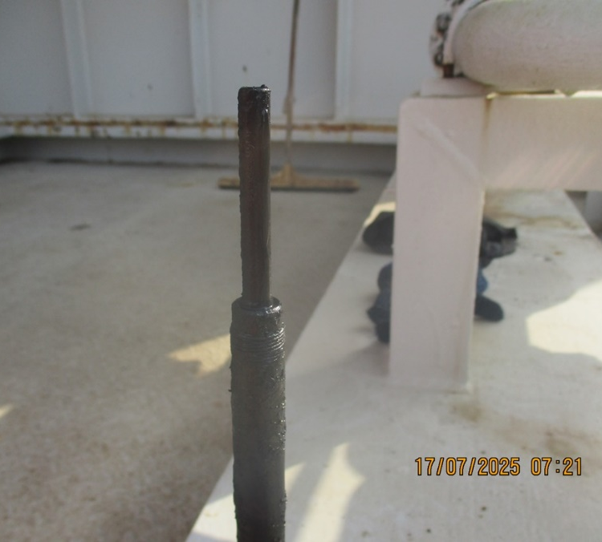 |  |  | 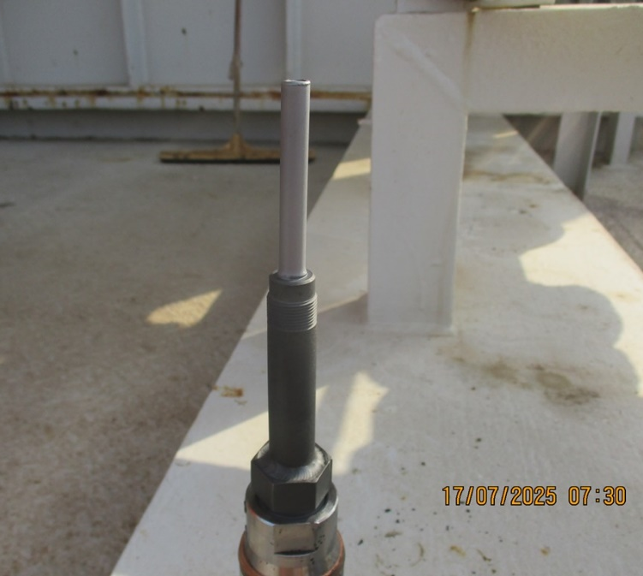
Comments

Tag No | Line No / Description | Pressure  (psi) | A/F Orientation | Scope of Work | New Probe Size / Specification | Probe Readings | Date | Tool Used | Location Access | Remedial Actions
53-XCP-1132 | 6-GP-532095-15150  6” HP Gas from Arab-C BH27 WHJ to PS3-B Production Manifold | 1500psi | 12 o Clock | Install New ER Probe | 6.5” Cylindrical T10  4500-T10-K03005-6.50.00-0-0 | Check – 755  Div – 74.4  M.Loss – 0.372  CR – N/A | 17-07-2025 | 25” | Access OK | None  Required
Access Fitting Picture |  |  |  | Removed Device |  |  | New Probe
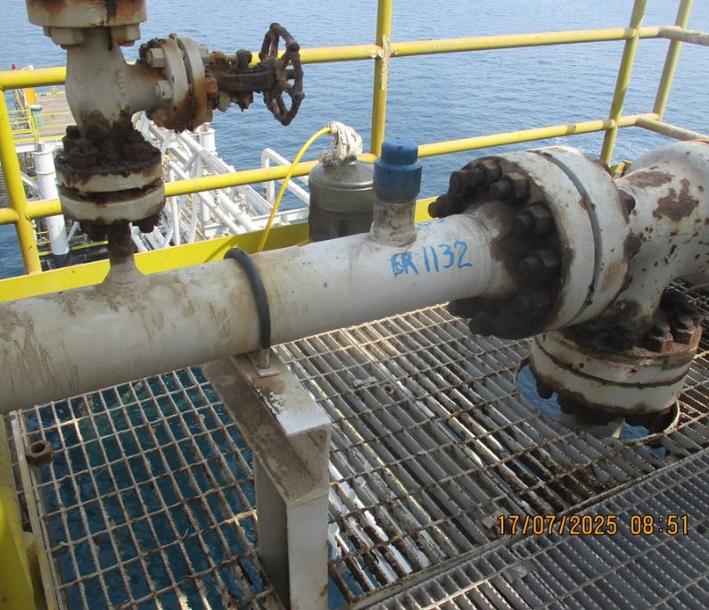 |  |  |  | 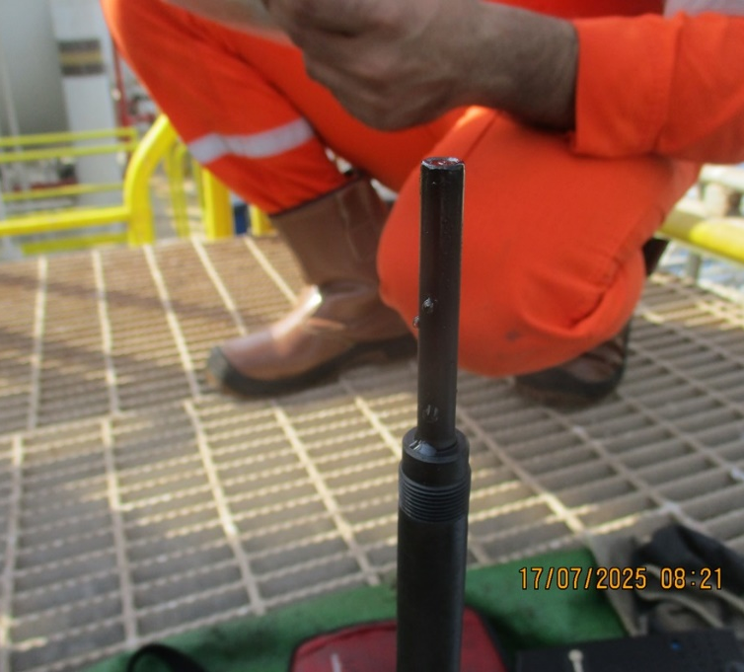 |  |  | 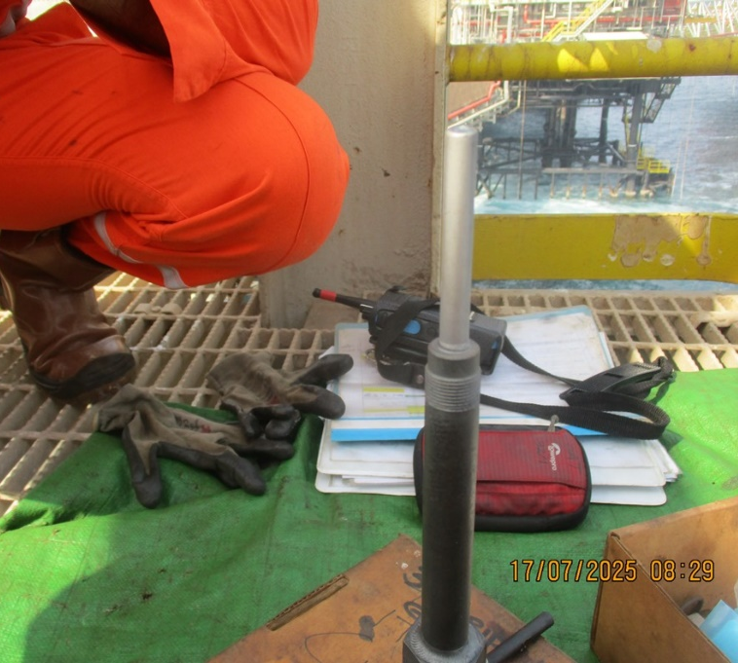
Comments

Tag No | Line No / Description | Pressure  (psi) | A/F Orientation | Scope of Work | Retrieved Coupons ID /  Holder Length | Coupon Appearance | Installed Coupons ID / Weight / Material / Date | Tool Used | Location Access | Remedial Actions
53-XCC-945 | 12-OC-530093-15144X  12” Oil Line from Production Manifold to Test Header | 100psi | 12 o Clock | Replace 3” Strip Coupons | MQ047 & MQ048  12.25” Holder | Dark in colour  Some soft sludge | NF801 – 37.0915  NF802 – 37.0069  C1018  17-07-2025 | 25” | Access OK  Fitting under grating | None Required
Access Fitting Photograph |  |  |  | Retrieved Coupons / Device Photograph |  |  | Installed Coupons / Device Photograph
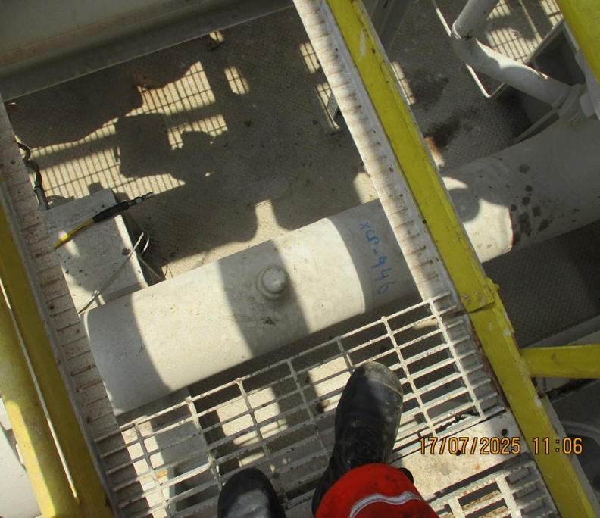 |  |  |  | 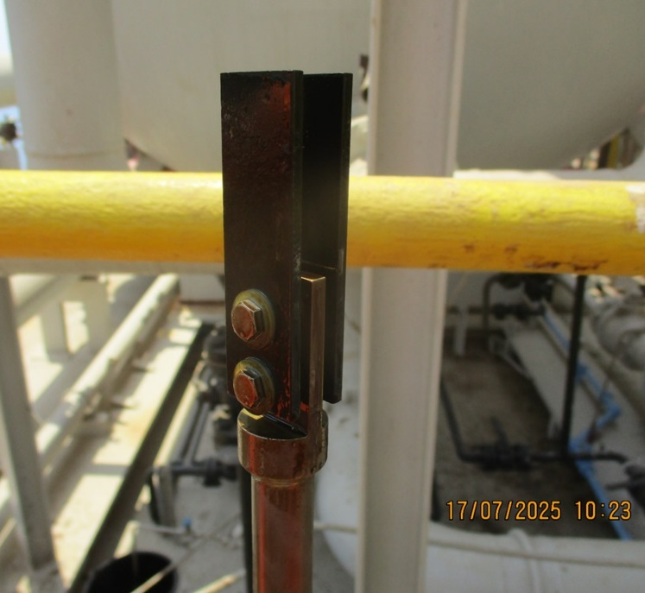 |  |  | 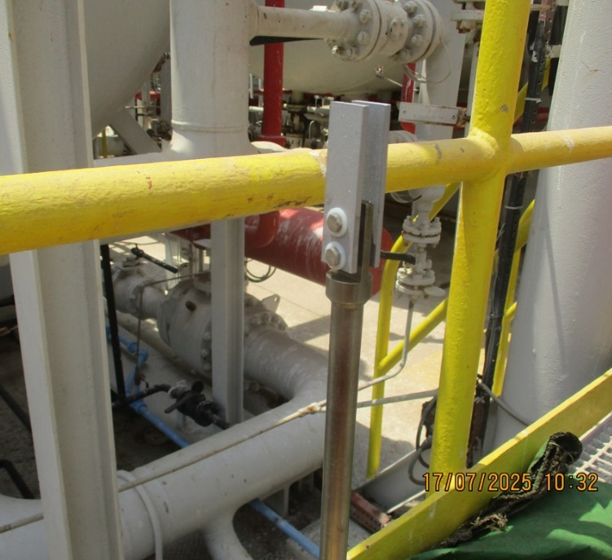
Comments

Tag No | Line No / Description | Pressure  (psi) | A/F Orientation | Scope of Work | New Probe Size / Specification | Probe Readings | Date | Tool Used | Location Access | Remedial Actions
53-XCP-946 | 12-OC-530093-15144X  12” Oil Line from Production Manifold to Test Header | 100psi | 12 o Clock | Install New ER Probe | N/A – Probe could not be retrieved | Previously Obtained | 17-07-2025 | 25” | Access for tool obstructed  Fitting under grating | Replace Probe during shutdown
Access Fitting Picture |  |  |  | Removed Device |  |  | New Probe
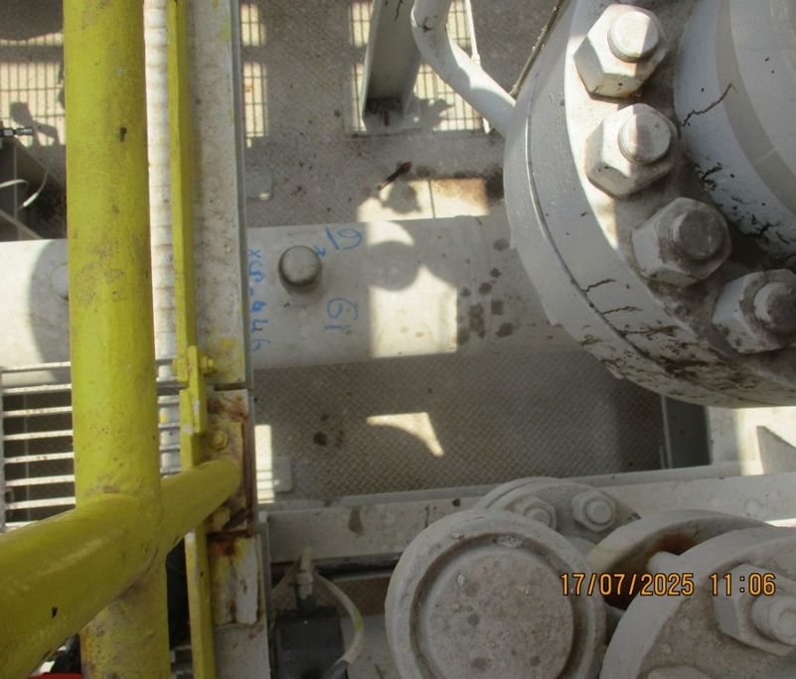 |  |  |  | 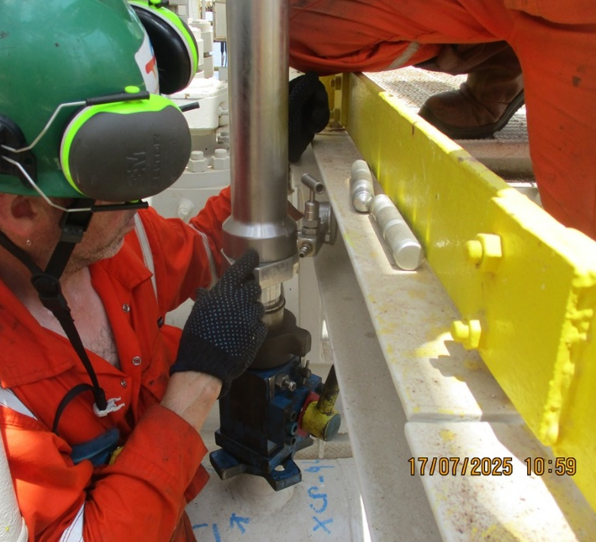
Comments
An attempt was made to retrieve the ER Probe at this location, but part of the platform structure obstructs the retrieval tool pressure gauge/bleed assembly so could not be retrieved. This location will need to be serviced during a shutdown.

Tag No | Line No / Description | Pressure  (psi) | A/F Orientation | Scope of Work | Retrieved Coupons ID /  Holder Length | Coupon Appearance | Installed Coupons ID / Weight / Material / Date | Tool Used | Location Access | Remedial Actions
53-XCC-1430 | 12-OC-530234-15151  12” Oil Inlet to V-5307 | 150psi | 12 o Clock | Replace 3” Strip Coupons | MQ033 & MQ044  12.25” Holder | Dark in colour  Pitting on leading edges | NE618- 37.0399  NE619 – 36.6463  C1018  17-07-2025 | 25” | Access OK | None Required
Access Fitting Photograph |  |  |  | Retrieved Coupons / Device Photograph |  |  | Installed Coupons / Device Photograph
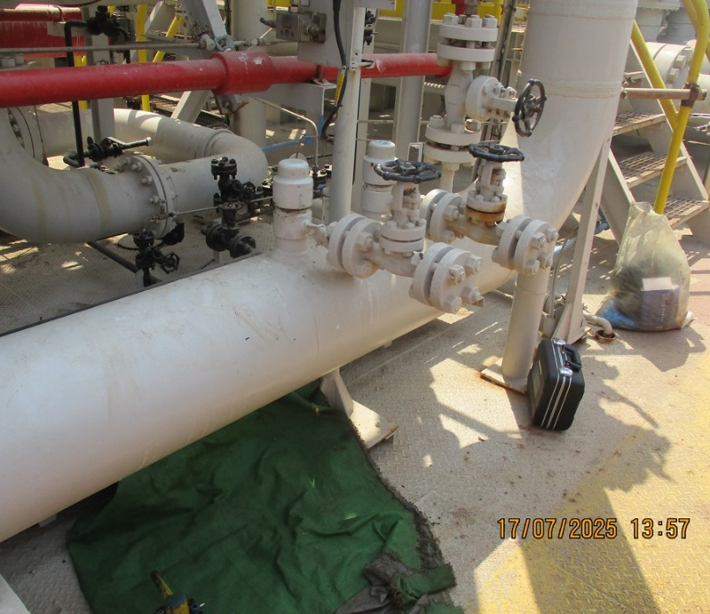 |  |  |  | 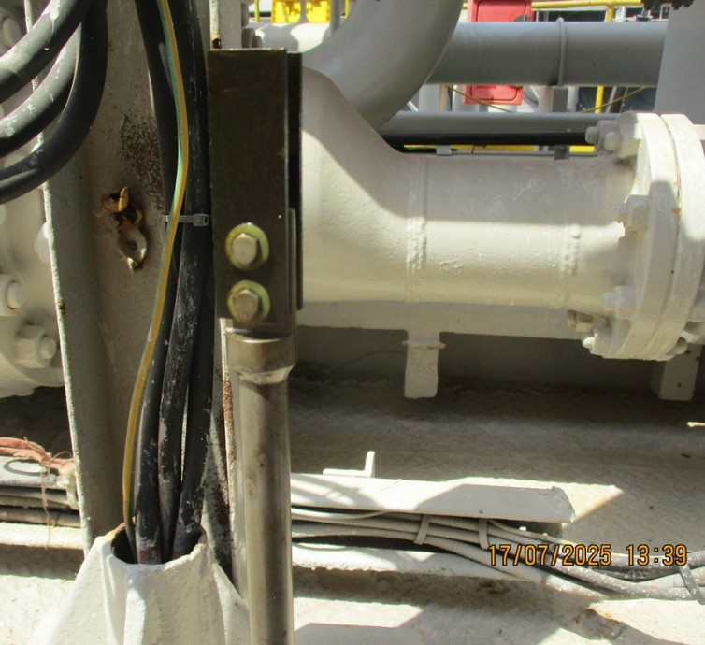 |  |  | 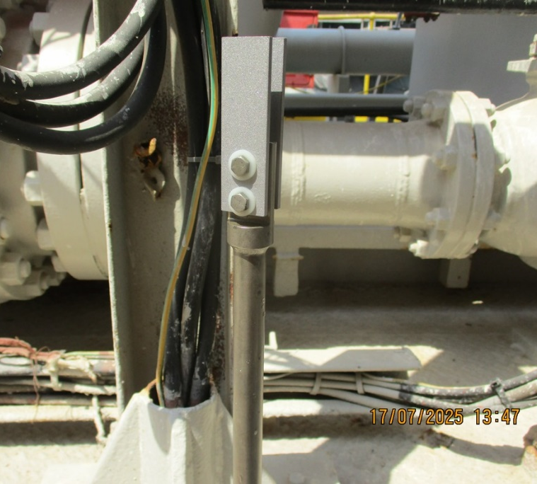
Comments

Tag No | Line No / Description | Pressure  (psi) | A/F Orientation | Scope of Work | Work Performed | Probe Readings | Date | Tool Used | Location Access | Remedial Actions
53-XCP-1429 | 12-OC-530234-15151  12” Oil Inlet to V-5307 | N/A | 12 o Clock | External Service of Access Fitting | Cap removed, threads brushed and re-greased | Obtained Previously | 17-07-2025 | N/A | Access OK | None Required
Access Fitting Picture
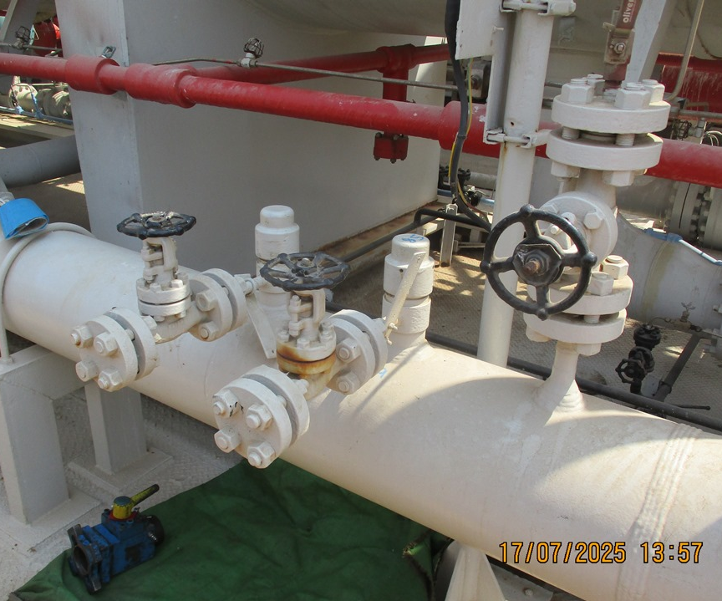

Comments

Tag No | Line No / Description | Pressure  (psi) | A/F Orientation | Scope of Work | Retrieved Coupons ID /  Holder Length | Coupon Appearance | Installed Coupons ID / Weight / Material / Date | Tool Used | Location Access | Remedial Actions
53-XCC-1001 | 14-OC-530274-31441M | 100psi | 12 o Clock | Replace 3” Strip Coupons | MQ037 & MQ038  13.50” Holder | Dark in colour  Some soft sludges | NE620 – 36.9794  NE621 – 36.7801  C1018  17-07-2025 | 25” | Access OK | None Required
Access Fitting Photograph |  |  |  | Retrieved Coupons / Device Photograph |  |  | Installed Coupons / Device Photograph
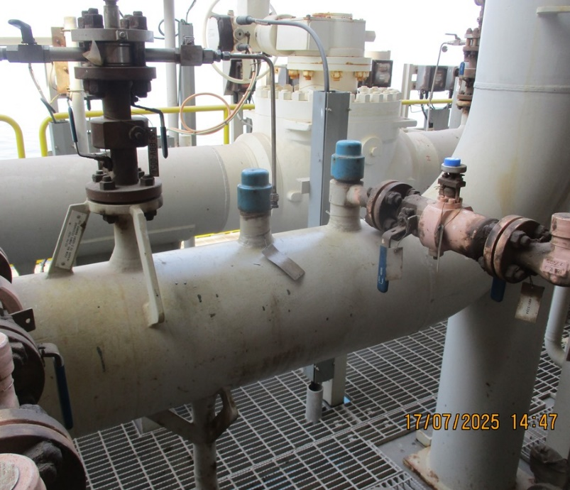 |  |  |  | 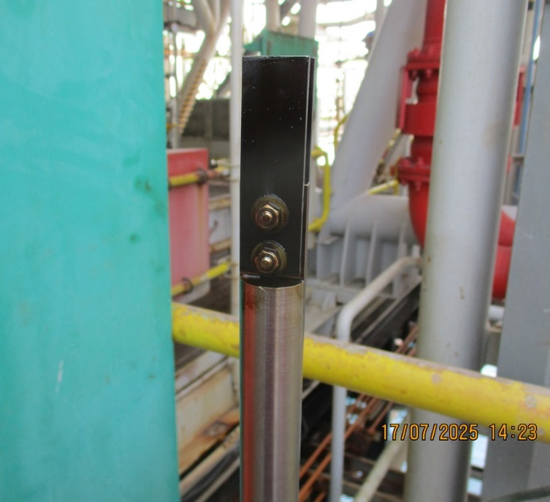 |  |  | 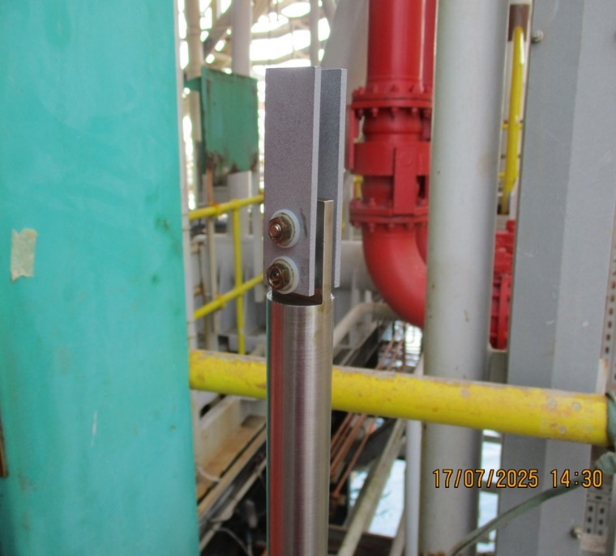
Comments

Observations & Recommendations

One of the ER Probe locations we had hoped to replace today on PS3-B Upper deck has a handrail obstruction. Arrangements have been made with the mechanical team to have the handrail removed to allow access for the tool.

24 Hour Lookahead
The plan for Friday 18th July is to complete the remaining work on PS3-B and hopefully complete all work on PS3-D

Stuart Dunthorne – Axess-Corrosion. – sdunthorne@axess.energy

